
OPC Unified Architecture
Release Candidate Specification
Part 5: SM Appendix
Version 1.70
November 18, 2006
Send comments to:
UAcomments@opcfoundation.org

Specification Type | Industry Standard Specification
Title: | OPC Unified Architecture  SM Appendix | Date: | November 18, 2006
Version: | Release Candidate 1.70 | Software | MS-Word
 |  | Source: | 0000.doc
Author: | OPC Foundation | Status: | Release Candidate

CONTENTS
Page
Appendix A : StateMachines 1
A.1 Scope 1
A.2 Examples of finite state machines 1
A.2.1 Simple state machine 1
A.2.2 State machine containing substates 2
A.3 Definition of finite state machine 2
A.4 Representation of finite state machines in the AddressSpace 3
A.4.1 StateMachineType 3
A.4.2 StateType 4
A.4.3 InitialStateType 5
A.4.4 TransitionType 5
A.4.5 FromState 5
A.4.6 ToState 6
A.4.7 HasCause 6
A.4.8 HasEffect 7
A.4.9 HasSubStateMachine 7
A.4.10 TransitionEventType 8
A.5 Examples of StateMachines in the AddressSpace 9
A.5.1 StateMachineType using inheritance 9
A.5.2 StateMachineType with a sub-machine using inheritance 10
A.5.3 StateMachineType using containment 11
A.5.4 Alternative approach of StateMachineType using containment 12
A.5.5 Example of a StateMachine having Transitions to sub-machines 13

FIGURES
Figure 1 – Example of a simple state machine 1
Figure 2 – Example of a state machine having a sub-machine 2
Figure 3 – Example of a StateMachineType using inheritance 9
Figure 4 – Example of a StateMachineType with a sub-machine using inheritance 10
Figure 5 – Example of a StateMachineType using containment 11
Figure 6 – Example of a StateMachineType using containment (alternative) 12
Figure 7 – Example of a state machine with transitions from sub-states 13
Figure 8 – Example of a StateMachineType having Transitions to sub-machines 14

TABLES
Table 1 – StateMachineType Definition 3
Table 2 – StateType Definition 5
Table 3 – InitialStateType Definition 5
Table 4 – TransitionType Definition 5
Table 5 – FromState ReferenceType 6
Table 6 – ToState ReferenceType 6
Table 7 – HasCause ReferenceType 7
Table 8 – HasEffect ReferenceType 7
Table 9 – HasSubStateMachine ReferenceType 8
Table 10 - TransitionEventType 8

OPC Foundation
____________

UNIFIED ARCHITECTURE –
FOREWORD
This specification is for developers of OPC UA clients and servers. The specification is a result of an analysis and design process to develop a standard interface to facilitate the development of servers and clients by multiple vendors that shall inter-operate seamlessly together.
Trademarks
Most computer and software brand names have trademarks or registered trademarks. The individual trademarks have not been listed here.
NON-EXCLUSIVE LICENSE AGREEMENT
The OPC Foundation, a non-profit corporation (the “OPC Foundation”), has defined a set of standard objects, interfaces and behaviour s associated with the objects intended to promote interoperability between automation/control applications, field systems/devices, and business/office applications in the process control industry.
The OPC specifications, sample software that demonstrates the implementation of the specifications, standard interface components deliverables and related documentation (collectively, the “OPC Materials”), form a set of standard objects, interfaces and behaviour that are based on the technology being used in the automation marketplace, and includes the use of Microsoft Technology as well providing interoperability to non Microsoft platforms. The technology defines standard objects, methods, and properties for servers of real-time information like distributed process systems, programmable logic controllers, smart field devices and analyzers in order to communicate the information that such servers contain to standard compliant technologies enabled devices (e.g., servers, applications, etc.).
The OPC Foundation will grant to you (the “User”), whether an individual or legal entity, a license to use, and provide User with a copy of, the current version of the OPC Materials so long as User abides by the terms contained in this Non-Exclusive License Agreement (“Agreement”). If User does not agree to the terms and conditions contained in this Agreement, the OPC Materials may not be used, and all copies (in all formats) of such materials in User’s possession must either be destroyed or returned to the OPC Foundation. By using the OPC Materials, User (including any employees and agents of User) agrees to be bound by the terms of this Agreement.
LICENSE GRANT:
Subject to the terms and conditions of this Agreement, the OPC Foundation hereby grants to User a non-exclusive, royalty-free, limited license to use, copy, display and distribute the OPC Materials in order to make, use, sell or otherwise distribute any products and/or product literature that are compliant with the standards included in the OPC Materials.
All copies of the OPC Materials made and/or distributed by User must include all copyright and other proprietary rights notices include on or in the copy of such materials provided to User by the OPC Foundation.
The OPC Foundation shall retain all right, title and interest (including, without limitation, the copyrights) in the OPC Materials, subject to the limited license granted to User under this Agreement.
WARRANTY AND LIABILITY DISCLAIMERS:
User acknowledges that the OPC Foundation has provided the OPC Materials for informational purposes only in order to help User understand Microsoft’s OLE/COM technology. THE OPC MATERIALS ARE PROVIDED “AS IS” WITHOUT WARRANTY OF ANY KIND, EXPRESS OR IMPLIED, INCLUDING, BUT NOT LIMITED TO, WARRANTIES OF PERFORMANCE, MERCHANTABILITY, FITNESS FOR A PARTICULAR PURPOSE OR NON-INFRINGEMENT. USER BEARS ALL RISK RELATING TO QUALITY, DESIGN, USE AND PERFORMANCE OF THE OPC MATERIALS. The OPC Foundation and its members do not warrant that the OPC Materials, their design or their use will meet User’s requirements, operate without interruption or be error free.
IN NO EVENT SHALL THE OPC FOUNDATION, ITS MEMBERS, OR ANY THIRD PARTY BE LIABLE FOR ANY COSTS, EXPENSES, LOSSES, DAMAGES (INCLUDING, BUT NOT LIMITED TO, DIRECT, INDIRECT, CONSEQUENTIAL, INCIDENTAL, SPECIAL OR PUNITIVE DAMAGES) OR INJURIES INCURRED BY USER OR ANY THIRD PARTY AS A RESULT OF THIS AGREEMENT OR ANY USE OF THE OPC MATERIALS.
GENERAL PROVISIONS:
This Agreement and User’s license to the OPC Materials shall be terminated (a) by User ceasing all use of the OPC Materials, (b) by User obtaining a superseding version of the OPC Materials, or (c) by the OPC Foundation, at its option, if User commits a material breach hereof. Upon any termination of this Agreement, User shall immediately cease all use of the OPC Materials, destroy all copies thereof then in its possession and take such other actions as the OPC Foundation may reasonably request to ensure that no copies of the OPC Materials licensed under this Agreement remain in its possession.
User shall not export or re-export the OPC Materials or any product produced directly by the use thereof to any person or destination that is not authorized to receive them under the export control laws and regulations of the United States.
The Software and Documentation are provided with Restricted Rights. Use, duplication or disclosure by the U.S. government is subject to restrictions as set forth in (a) this Agreement pursuant to DFARs 227.7202-3(a); (b) subparagraph (c)(1)(i) of the Rights in Technical Data and Computer Software clause at DFARs 252.227-7013; or (c) the Commercial Computer Software Restricted Rights clause at FAR 52.227-19 subdivision (c)(1) and (2), as applicable. Contractor / manufacturer are the OPC Foundation,. 16101 N. 82nd Street, Suite 3B, Scottsdale, AZ, 85260-1830
Should any provision of this Agreement be held to be void, invalid, unenforceable or illegal by a court, the validity and enforceability of the other provisions shall not be affected thereby.
This Agreement shall be governed by and construed under the laws of the State of Minnesota, excluding its choice or law rules.
This Agreement embodies the entire understanding between the parties with respect to, and supersedes any prior understanding or agreement (oral or written) relating to, the OPC Materials.
- : StateMachines
  - Scope
This Appendix describes the basic infrastructure to model finite state machines in OPC UA. It defines ObjectTypes, VariableTypes and ReferenceTypes and explains how they should be used.
This Appendix is normative, i.e. the types defined in the Appendix have to be used as defined. However, it is not required but strongly recommended that a server uses these types to expose its state machines. The defined types may be subtyped to refine their behaviour.
The scope of the state machines described in this Appendix is to provide an appropriate foundation for state machines needed by [UA Part 9] and [UA Part 10]. It does not provide more complex functionality of a state machine like parallel states, forks and joins, history states, choices and junctions etc. However, the base state machine defined in this Appendix can be extended to support such concepts.
The following clauses describe examples of state machines, define state machines in the context of this Appendix and define the representation of state machines in OPC UA. Finally, some examples of state machines, represented in OPC UA, are given.
  - Examples of finite state machines
    - Simple state machine
The following example gives an overview over the base features that the state machines defined in this Appendix will support. In the following clause a more complex example is given, that also supports sub-machines.
Figure 1 gives an overview over a simple state machine. It contains the three states “State1”, “State2” and “State3”. There are transitions from “State1” to “State2”, “State2” to “State2”, etc. Some of the transitions give additional information what causes (or triggers) the transition, e.g. the call of “Method1” for the transition from “State1” to “State2”. The effect (or action) of the transition can also be specified, e.g. the generation of an Event of the “EventType1” in the same transition. The notation of the cause is just writing it to the transition, the effect is prefixed with a “/”. More than one cause or effect are separated by a “,”. Not every transition has to have a cause or effect, for example the transition between “State2” and “State3”.
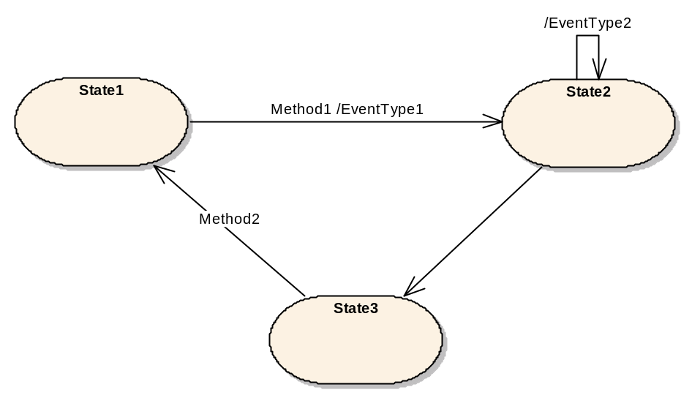
Figure 1 – Example of a simple state machine
For simplicity, the state machines described in this Appendix will only support causes in form of specifying Methods that have to be called and effects in form of EventTypes of Events that are generated, if the transition is used. However, the defined infrastructure allows extending this supporting different causes and effects, if needed.
    - State machine containing substates
Figure 2 shows an example of a state machine where “State6” is a sub-machine. This means, that when the overall state machine is in State6, this state can be distinguish to be in the sub-states “State7” or “State8”. Sub-machines can be nested, i.e. “State7” could be another sub-machine.
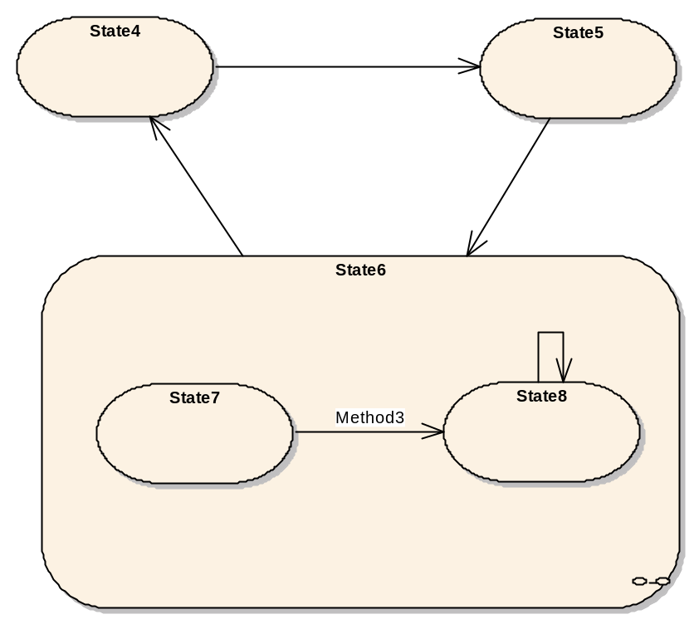
Figure 2 – Example of a state machine having a sub-machine
  - Definition of finite state machine
The infrastructure of state machines defined in this Appendix only deals with the basic of state machines needed to support [UA Part 9] and [UA Part 10]. The intention is to keep the basic simple but extensible.
For the state machines defined in this Appendix we assume state machines that are typed and where instances of a type cannot change there state machine. However, the base concepts defined in this Appendix can also be used to define more flexible state machines.
Therefore we distinguish between StateMachineType and StateMachine. The StateMachineType contains the description of the state machine – its states, transitions, etc. – whereas the StateMachine is an instance of the StateMachineType and only contains the current state.
Each StateMachine contains information about the current state. If the StateMachineType has sub-machines, the StateMachine also contains information about the current state of the sub-machines.
Each StateMachineType has one or more States. For simplicity we do not distinguish between different States like the start or the end states.
Each State can have one or more sub-machines by referencing a StateMachine.
Each StateMachineType has one or more Transitions. A Transition is directed and points from one State to another State.
Each Transition can have one or more Causes. A Cause leads a StateMachine to change its current State from the source of the Transition to its target. In this Appendix we only specify Method calls to be Causes of Transitions.
Each Transition can have one or more Effects. An Effect occurs if the Transition is used to change the State of a StateMachine. In this Appendix we only specify the generation of Events to be Effects of a Transition.
Although this Appendix only specifies simple concepts for state machines, the provided infrastructure is extensible. If needed, special States can be defined as well as additional Causes or Effects.
  - Representation of finite state machines in the AddressSpace
    - StateMachineType
A StateMachineType is represented as a special ObjectType in the AddressSpace formally defined in Table 1. There are two possibilities to use the base StateMachineType: inheritance or containment. If the main reason of an Object in the AddressSpace is to provide a state machine, its ObjectType should inherit from the StateMachineType. If the main purpose is not to provide a state machine then the Object should contain another Object representing the state machine. An example of the first case are Programs defined in [UA Part 10], an example for the latter case are Conditions defined in [UA Part 9].
Table 1 – StateMachineType Definition
Attribute | Value
BrowseName | StateMachineType
IsAbstract | False
References |  | Node  Class | BrowseName | DataType | TypeDefinition | Modelling  Rule
Subtype of the BaseObjectType defined in Clause 6.2 of [UA Part 5]. Note that a Reference to this subtype is not shown in the definition of the BaseObjectType.
HasComponent |  | Variable | CurrentStateBrowseName | QualifiedName | BaseDataVariableType | New
HasComponent |  | Variable | CurrentStateDisplayName | LocalizedText | BaseDataVariableType | New
HasComponent |  | Variable | CurrentStateNumber | UInt32 | BaseDataVariableType | New
HasComponent |  | Variable | CurrentCollapsedStateDisplayName | LocalizedText | BaseDataVariableType | New
HasComponent |  | Variable | LastTransitionBrowseName | QualifiedName | BaseDataVariableType | New
HasComponent |  | Variable | LastTransitionDislayName | LocalizedText | BaseDataVariableType | New
HasComponent |  | Variable | LastTransitionNumber | UInt32 | BaseDataVariableType | New
HasComponent |  | Variable | TimeOfLastTransition | UtcTime | BaseDataVariableType | New

The CurrentStateBrowseName Variable is used for instances of this type to point to its current state. It does not consider sub-states. The state of the sub-machines can be gained from accessing the according Variable of the sub-machine.
The CurrentStateDisplayName Variable contains the DisplayName of the State Object representing the current state. As an example, this Variable can be used for user interfaces displaying the current state.
The CurrentStateDisplayName Variable must always have the value of the DisplayName Attribute of the State that is referenced by the CurrentStateBrowseName Variable.
The CurrentStateNumber Variable contains the StateNumber of the current state. Each State Object contains a StateNumber that must be unique in the context of States directly contained in a StateMachine – sub-machines may use the same numbers so their States cannot be identified that way. As an example the CurrentStateNumber can be used to programmatically handle states. Typically it is easier to handle integer values than strings in that case.
The CurrentStateNumber Variable must always have the value of the StateNumber Variable of the State that is referenced by the CurrentStateBrowseName Variable.
The CurrentCollapsedStateDisplayName Variable contains the DisplayName of a State that is the current state of the StateMachine or one of its sub-machines. There is no rule specified which state or sub-state should be taken. It is up to the server and probably depends on the concrete StateMachineType which state to choose. However, if there are no sub-machines for the current state then the value has to be the same as for the CurrentStateDisplayName Variable. The intention is that clients will use this Variable if they display the current state considering sub-state.
The LastTransitionBrowseName Variable is used for instances of this type to point to the last Transition that was fired. It does not consider sub-states. The Transition of the sub-machines can be gained from accessing the according Variable of the sub-machine. If no Transition was used since the StateMachine was created, the value must be set to null.
The LastTransitionDisplayName Variable contains the DisplayName of the Transition Object representing the last Transition that was fired. As an example, this Variable can be used for user interfaces displaying the last Transition.
The LastTransitionDisplayName Variable must always have the value of the DisplayName Attribute of the Transition that is referenced by the LastTransitionBrowseName Variable.
The LastTransitionNumber Variable identifies the TansitionNumber of the last Transition that was fired. Each Transition Object contains a TransitionNumber that must be unique in the context of Transitions directly contained in a StateMachine – sub-machines may use the same numbers so their Transitions cannot be identified that way. If no Transition was used since the StateMachine was created, the value must be set to null.
The TimeOfLastTransition Variable indicates the time of the last Transition that was fired. It does not consider sub-machines. The time of the last Transition of a sub-machine can be gained form accessing the according Variable of the sub-machine. If no Transition was used since the StateMachine was created, the value must be set to null.
All States and Transitions of a state machine are bound to it using HasComponent References. However, the base StateMachineType does not contain any States or Transitions.
All sub-machines are also bound to the state machine using HasComponent References, but the base StateMachineType does not contain any sub-machines.
StateMachines can be defined on two levels. Either by subtyping the StateMachineType and thereby defining reusable StateMachineTypes or by using the base StateMachineType as InstanceDeclaration of another ObjectType and adding States and Transitions on this InstanceDeclaration. Examples for both approaches are given in Clause A.5 .
    - StateType
States of a StateMachine are represented as Objects of the ObjectType StateType formally defined in Table 2.
Table 2 – StateType Definition
Attribute | Value
BrowseName | StateType
IsAbstract | False
References |  | NodeClass | BrowseName | DataType | TypeDefinition | ModellingRule
Subtype of the BaseObjectType defined in Clause 6.2 of [UA Part 5]. Note that a Reference to this subtype is not shown in the definition of the BaseObjectType.
HasProperty |  | Variable | StateNumber | UInt32 | PropertyType | New
HasSubtype |  | ObjectType | InitialStateType

    - InitialStateType
The InitalStateType is a subtype of the StateType and is formally defined in Table 2. An Object of the InitialStateType represents the initial State of a StateMachine, i.e. the State that will initially be entered. Each StateMachine can have at most one State of type InitialStateType, but a StateMachine does not have to have a State of this type.
Table 3 – InitialStateType Definition
Attribute | Value
BrowseName | InitialStateType
IsAbstract | False
References |  | NodeClass | BrowseName | DataType | TypeDefinition | ModellingRule
Inherit the Properties of the StateType defined in Clause A.4.2

    - TransitionType
Transitions of a StateMachine are represented as Objects of the ObjectType TransitionType formally defined in Table 4.
Each valid Transition must have exactly one FromState Reference and exactly one ToState Reference, each pointing to an Object of the ObjectType StateType.
Each Transition can have one or more HasCause References pointing to the cause that triggers the Transition.
Each Transition can have one or more HasEffect References pointing to the effects that occur when the Transition was triggered.
Table 4 – TransitionType Definition
Attribute | Value
BrowseName | TransitionType
IsAbstract | False
References |  | NodeClass | BrowseName | DataType | TypeDefinition | ModellingRule
Subtype of the BaseObjectType defined in Clause 6.2 of [UA Part 5]. Note that a Reference to this subtype is not shown in the definition of the BaseObjectType.
HasProperty |  | Variable | TransitionNumber | UInt32 | PropertyType | New

    - FromState
The FromState ReferenceType is a concrete ReferenceType and can be used directly. It is a subtype of NonHierarchicalReferences.
The semantic of this ReferenceType is to point form a Transition to the starting State the Transition connects.
The SourceNode of this ReferenceType must be an Object of the ObjectType TransitionType or one of its subtypes. The TargetNode of this ReferenceType must be an Object of the ObjectType StateType or one of its subtypes.
The representation of the FromState ReferenceType in the AddressSpace is specified in Table 5.
Table 5 – FromState ReferenceType
Attributes | Value
BrowseName | FromState
InverseName | ToTransition
Symmetric | False
IsAbstract | False
References | NodeClass | BrowseName | Comment

    - ToState
The ToState ReferenceType is a concrete ReferenceType and can be used directly. It is a subtype of NonHierarchicalReferences.
The semantic of this ReferenceType is to point form a Transition to the ending State the Transition connects.
The SourceNode of this ReferenceType must be an Object of the ObjectType TransitionType or one of its subtypes. The TargetNode of this ReferenceType must be an Object of the ObjectType StateType or one of its subtypes.
References of this ReferenceType may be only exposed uni-directional. Sometimes this is required, for example, if a Transition points to a State of a sub-machine.
The representation of the ToState ReferenceType in the AddressSpace is specified in Table 6.
Table 6 – ToState ReferenceType
Attributes | Value
BrowseName | ToState
InverseName | FromTransition
Symmetric | False
IsAbstract | False
References | NodeClass | BrowseName | Comment

    - HasCause
The HasCause ReferenceType is a concrete ReferenceType and can be used directly. It is a subtype of NonHierarchicalReferences.
The semantic of this ReferenceType is to point form a Transition to something that causes the Transition. In this Appendix we only define Methods as Causes. However, the ReferenceType is not restricted to point to Methods.
The SourceNode of this ReferenceType must be an Object of the ObjectType TransitionType or one of its subtypes. The TargetNode can be of any NodeClass.
The representation of the HasCause ReferenceType in the AddressSpace is specified in Table 7.
Table 7 – HasCause ReferenceType
Attributes | Value
BrowseName | HasCause
InverseName | MayBeCausedBy
Symmetric | False
IsAbstract | False
References | NodeClass | BrowseName | Comment

    - HasEffect
The HasEffect ReferenceType is a concrete ReferenceType and can be used directly. It is a subtype of NonHierarchicalReferences.
The semantic of this ReferenceType is to point form a Transition to something that will be effected when the Transition is triggered. In this Appendix we only define EventTypes as Effects. However, the ReferenceType is not restricted to point to EventTypes.
The SourceNode of this ReferenceType must be an Object of the ObjectType TransitionType or one of its subtypes. The TargetNode can be of any NodeClass.
The representation of the HasEffect ReferenceType in the AddressSpace is specified in Table 8.
Table 8 – HasEffect ReferenceType
Attributes | Value
BrowseName | HasEffect
InverseName | MayBeEffectedBy
Symmetric | False
IsAbstract | False
References | NodeClass | BrowseName | Comment

    - HasSubStateMachine
The HasSubStateMachine ReferenceType is a concrete ReferenceType and can be used directly. It is a subtype of NonHierarchicalReferences.
The semantic of this ReferenceType is to point from a State to a StateMachine containing the sub-states of the State.
The SourceNode of this ReferenceType must be an Object of the ObjectType StateType or one of its subtypes. The TargetNode must be an Object of the ObjectType StateMachineType. Each Object can be the TargetNode of at most one HasSubStateMachine Reference.
The SourceNode (the State) and the TargetNode (the sub-machine) must belong to the same StateMachine, i.e. both must be referenced from the same Object of type StateMachineType using a HasComponent Reference or a subtype of HasComponent.
The representation of the HasSubStateMachine ReferenceType in the AddressSpace is specified in Table 9.
Table 9 – HasSubStateMachine ReferenceType
Attributes | Value
BrowseName | HasSubStateMachine
InverseName | SubStateMachineOf
Symmetric | False
IsAbstract | False
References | NodeClass | BrowseName | Comment

    - TransitionEventType
The TransitionEventType is a subtype of the BaseEventType. It can be used to generate an Event identifying that a Transition of a StateMachine was triggered. It is formally defined in Table 10.
Table 10 - TransitionEventType
Attribute | Value
BrowseName | TransitionEventType
IsAbstract | True
References | NodeClass | BrowseName | DataType | TypeDefinition | ModellingRule
Inherit the Properties of the base BaseEventType defined in Clause 6.4.2
HasProperty | Variable | TransitionNumber | UInt32 | PropertyType | New
HasProperty | Variable | FromStateNumber | UInt32 | PropertyType | New
HasProperty | Variable | FromStateNumberSubMachinePath | String | PropertyType | New
HasProperty | Variable | ToStateNumber | Uint32 | PropertyType | New
HasProperty | Variable | ToStateNumberSubMachinePath | String | PropertyType | New

The TransitionEventType inherits the Properties of the BaseEventType.
The inherited Property SourceNode must be filled with the NodeId of the StateMachine instance were the Transition occurs. If the Transition occurs in a sub-machine, then the NodeId of the sub-machine has to be used. If the Transition occurs between a StateMachine and a sub-machine, then the NodeId of theStateMachine has to be used, independent of the direction of the Transition.
The TransitionNumber Property identifies the Transition that triggered the Event.
The FromStateNumber Property identifies the StateNumber of the originating State of the Transition.
Since the Transition could start from a State of a sub-machine the FromStateNumber Property is ambiguous. Therefore the Property FromStateNumberSubMachinePath identifies the path to the sub-machine containing the state starting from the NodeId available in the SourceNode Property. If the State is not in a sub-machine, ToStateNumberSubMachinePath is set to null. The String uses the syntax of the TranslateBrowsePathsToNodeIds service defined in [UA Part 4] to specify the path.
The ToStateNumber Property identifies the StateNumber of the terminal State in the Transition.
Since the Transition could point to a State of a sub-machine the ToStateNumber Property is ambiguous. Therefore the Property ToStateNumberSubMachinePath identifies the path to the sub-machine containing the state starting from the NodeId available in the SourceNode Property. If the State is not in a sub-machine, ToStateNumberSubMachinePath is set to null. The String uses the syntax of the TranslateBrowsePathsToNodeIds service defined in [UA Part 4] to specify the path.
  - Examples of StateMachines in the AddressSpace
    - StateMachineType using inheritance
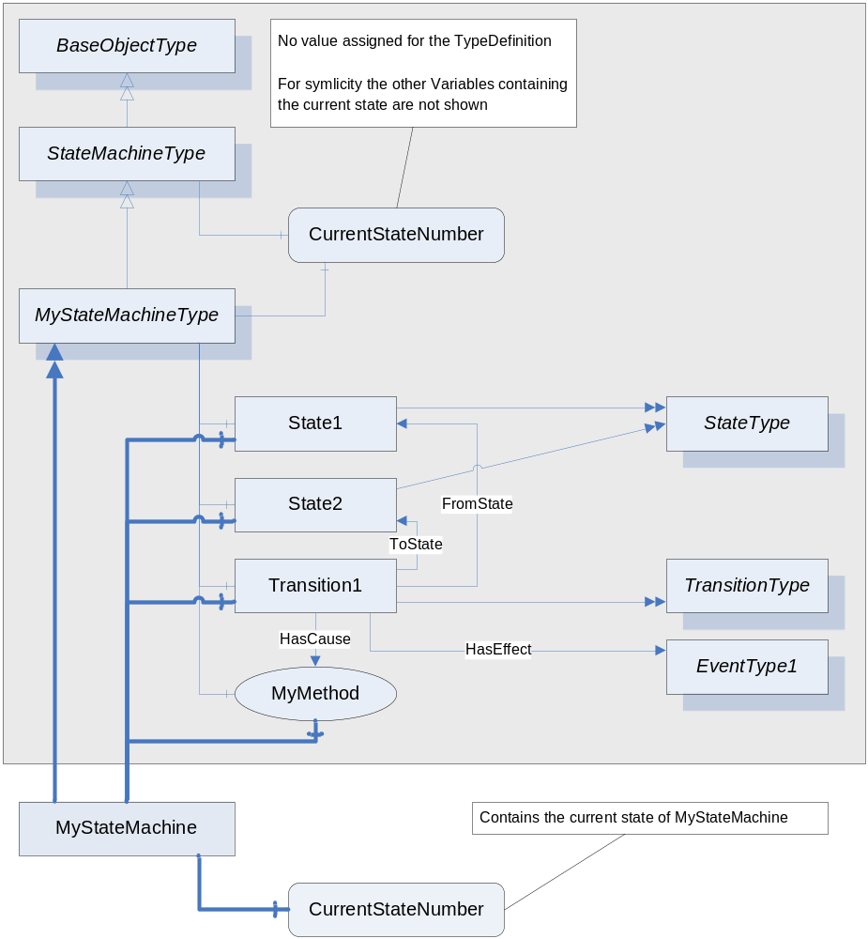
Figure 3 – Example of a StateMachineType using inheritance
In Figure 3 an example of a StateMachine is given using the Notation defined in Appendix xxx. First, a new state machine type is defined, called “MyStateMachineType”, inheriting from the base StateMachineType. It contains two States, “State1” and “State2” and a Transition “Transition1” between them. The Transition points to a Method “MyMethod” as the cause of the Transition and an EventType “EventType1” as the effect of the Transition.
Instances of “MyStateMachineType” can be created, for example “MyStateMachine”. It has a Variable “CurrentStateNumber” representing the current state. Note that the other Variables representing the current state are omitted in the Figure for simplicity. The “MyStateMachine” Object directly references the information of the StateMachine – States and Transitions – since they have the ModellingRule “Shared” (not shown in the Figure). In the example this is also true for “MyMethod” – other StateMachines may have non-shared Methods.
    - StateMachineType with a sub-machine using inheritance
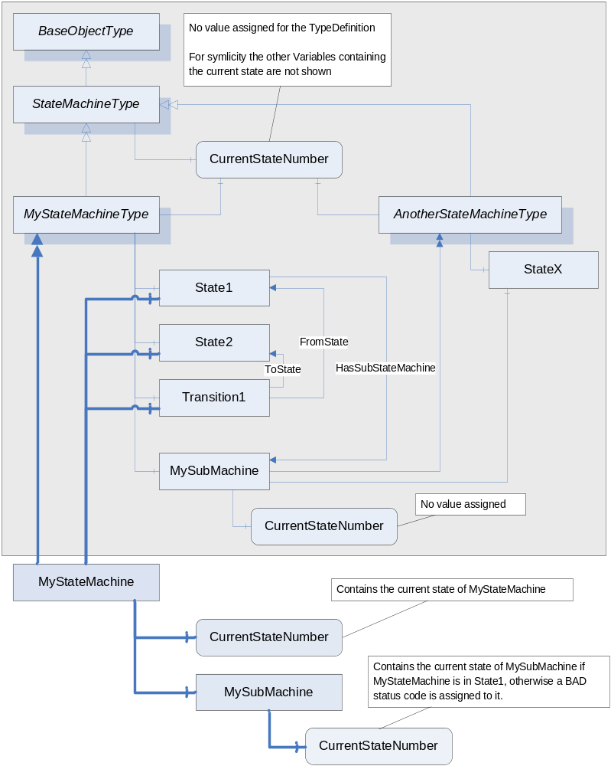
Figure 4 – Example of a StateMachineType with a sub-machine using inheritance
Figure 4 gives an example of a StateMachineType having a sub-machine for its “State1”. For simplicity no effects and causes are shown, as well as type information for the states or ModellingRules.
The “MyStateMachineType” contains an Object “MySubMachine” of type “AnotherStateMachineType” representing a sub-machine. It has the ModellingRule “New” not shown in the Figure. The “State1” references this Object with a HasSubStateMachine Reference, thus it is a sub-machine of “State1”. Since “MySubMachine” is an Object of type “AnotherStateMachineType” it references its shared components – in this case only “StateX” and has a Variable representing the current state. Since it is used as an InstanceDeclaration, no value is assigned to this Variable.
An Object of “MyStateMachineType”, called “MyStateMachine”, does not only reference the shared components of “MyStateMachineType” and has Variables for the current state, but also has an Object “MySubMachine” and Variables representing the current state of the sub-machine. Since the sub-machine is only used when “MyStateMachine” is in “State1”, a client would get a BAD StatusCode assigned for the Variables if “MyStateMachine” is in a different state.
    - StateMachineType using containment
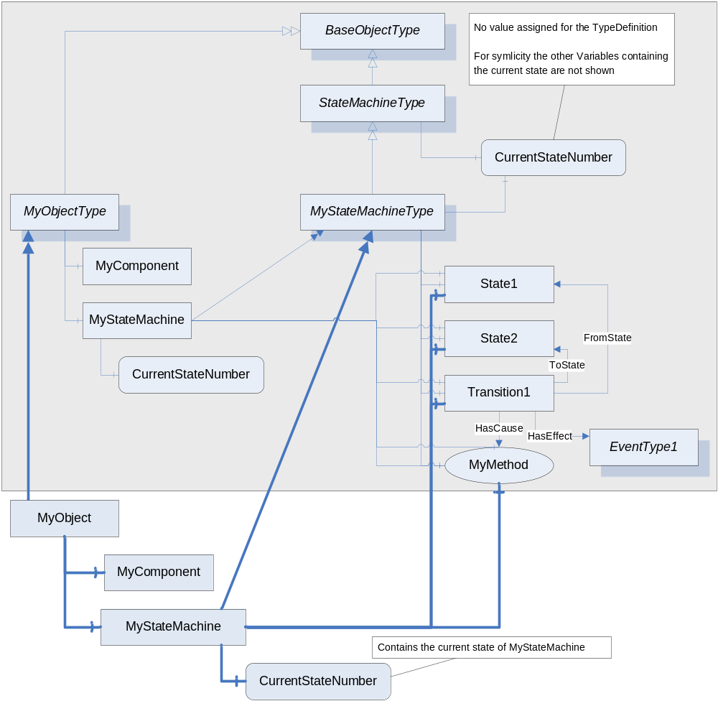
Figure 5 – Example of a StateMachineType using containment
Figure 5 gives an example of an ObjectType not only representing a StateMachine but also having some other functionality. The ObjectType “MyObjectType” has an Object “MyComponent” representing this other functionality. But is also contains a StateMachine “MyStateMachine” of the type “MyStateMachineType”. Objects of “MyObjectType” also contain such an Object representing the StateMachine and a Variable containing the current state of the StateMachine, as shown in the Figure.
    - Alternative approach of StateMachineType using containment
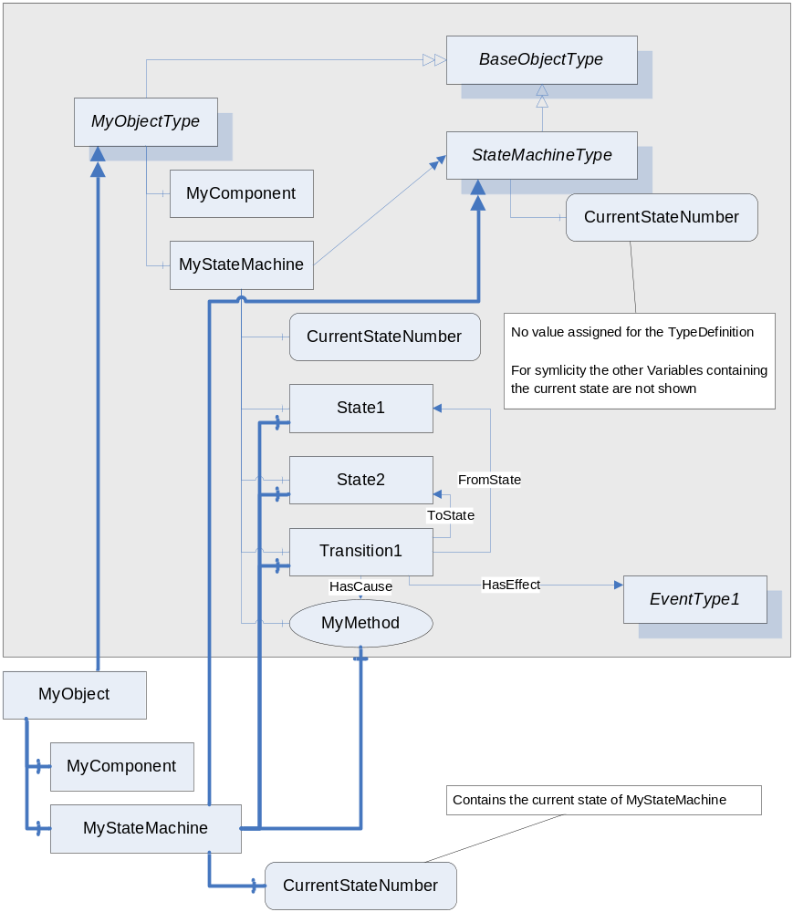
Figure 6 – Example of a StateMachineType using containment (alternative)
Figure 6 gives an example of an alternative way of modelling an ObjectType not only representing a StateMachine but also having some other functionality. The ObjectType “MyObjectType” has an Object “MyComponent” representing this other functionality. But is also contains a StateMachine “MyStateMachine” of the base StateMachine type “StateMachineType”. The States are not defined by a subtype of “StateMachineType” but directly as InstanceDeclaration of “MyObjectType”. This approach is suitable if it is clear that the StateMachine is only used in the context of “MyObjectType”. The States still have the ModellingRule “Shared” and are only references from the Objects of type “MyObjectType”.
    - Example of a StateMachine having Transitions to sub-machines
The StateMachines shown so far only had Transitions between States on the same level, i.e. on the same StateMachine. Of cause, it is possible and often required to have Transitions between States of the StateMachine and States of its sub-machine.
Because a sub-machine can be defined by another StateMachineType and this type can be used in several places, it is not possible to add a bi-directional Reference from one of the shared States of the sub-machine to another StateMachine. In this case it is suitable to expose the FromState or ToState References uni-directional, i.e. only pointing from the Transition to the State and not have the other direction browsable. If a Transition points from a State of a sub-machine to a State of another sub-machine, both, the FromState and the ToState Reference, are handled uni-directional.
A Client must be able to handle the information of a StateMachine if the ToState and FromState References are only exposed as forward References and the inverse References are omitted.
Figure 7 gives an example of a state machine having a transition from a sub-state to a state.
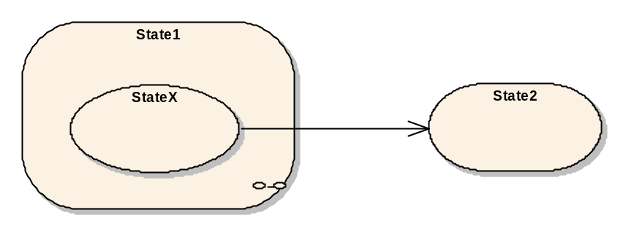
Figure 7 – Example of a state machine with transitions from sub-states
In Figure 8, the representation of this example as StateMachineType in the AdressSpace is given. The “Transition1”, part of the definition of “MyStateMachineType”, points to the “StateX” of the StateMachineType “AnotherStateMachineType”. The Reference is only exposed as forward Reference and the inverse Reference is omitted. Thus, there is no Reference from the “StateX” of “AnotherStateMachineType” to any part of “MyStateMachineType” and “AnotherStateMachineType” can be used in other places as well.
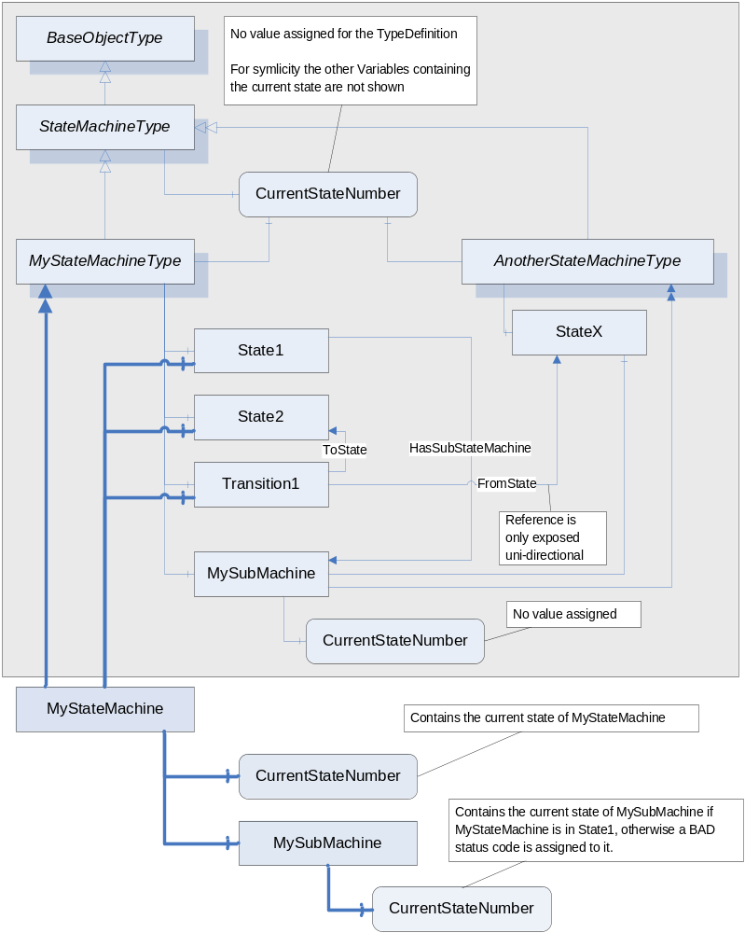
Figure 8 – Example of a StateMachineType having Transitions to sub-machines

